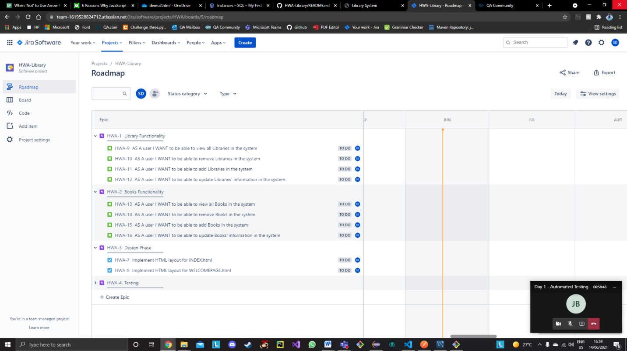**Jira Screenshots- Roadmap with user stories constructing Sprint**

**Jira Screenshot- Sprint Board (Scrum)**

